STUDENT ACCOMMODATION FINDER

Project Report
A Web-Based PG and Hostel Searching Platform

Technology Stack:
HTML | CSS | Bootstrap | JavaScript | AJAX | PHP | MySQL | React JS

Submitted For:
Internshala Project Submission

Prepared By:
Your Name: Kirti Sharma

Year: 2026

2. Project Overview

Student Accommodation Finder is a responsive web application designed to help students search and explore suitable PG (Paying Guest) and hostel accommodations.
The platform allows users to view property listings, check detailed property information, explore amenities, filter properties based on city, budget, and gender preferences, and mark properties as interested.
The project combines frontend, backend, database, and modern web technologies to simulate a real-world accommodation searching platform.
The application is developed using HTML, CSS, Bootstrap, JavaScript, AJAX, PHP, MySQL, and React.

3. Project Objectives
The main objectives of this project are:
- To design a responsive accommodation searching website.
- To provide students with an easy way to find PG and hostel facilities.
- To create dynamic web pages using PHP and MySQL.
- To implement user authentication using PHP sessions.
- To allow users to shortlist interested properties.
- To use AJAX for performing actions without page refresh.
- To integrate React components into the project.
- To develop a user-friendly interface.

4. Problem Statement

Finding suitable accommodation is a major challenge for students who move to new cities for education.
Students often face problems such as:
- Lack of verified accommodation information.
- Difficulty comparing prices.
- No proper information about facilities and amenities.
- Time-consuming manual searching.
This project provides a digital solution where students can search, filter, and save suitable accommodation options easily.

5. Technology Stack
Frontend Technologies
- HTML5
- CSS3
- Bootstrap 5
- JavaScript
- React JS
Backend Technology
- PHP
Database
- MySQL
Advanced Technologies
- AJAX
- React Components
Development Environment
- XAMPP Server
- Visual Studio Code
- phpMyAdmin

6. Functional Requirements
6.1 Property Listing
The system displays available PG and hostel properties with:
- Property image
- Property name
- City
- Price
- Gender type
- Rating
Users can filter properties by:
- City
- Budget
- Gender

6.2 Property Details
Each property contains:
- Large property image
- Address
- Price details
- Gender availability
- Rating
- Description
- Amenities
Example Amenities:
- WiFi
- Food
- Laundry
- Parking

6.3 User Authentication
The system provides:
Registration
Users can create an account using:
- Name
- Email
- Password
- Phone number
Login
Registered users can login and access interested properties.

6.4 Interested Property Feature
Users can mark properties as interested.
The selected property is stored in the database using AJAX without refreshing the page.
Users can view saved properties in:
My Interested Properties
and remove properties when required.

7. Database Design
Database Name:
student_accommodation
The database contains the following tables:

Users Table
Field | Description
id | User ID
name | User Name
email | Email Address
password | User Password
phone | Contact Number

Properties Table
Field | Description
id | Property ID
name | Property Name
city | Location
address | Property Address
price | Monthly Rent
gender | Boys/Girls/Both
rating | Property Rating
description | Details
image | Property Image

Amenities Table
Field | Description
id | Amenity ID
name | Amenity Name

Property_Amenities Table
Used to create a relationship between properties and amenities.
Fields:
- property_id
- amenity_id

Interested_Users Table
Stores user shortlisted properties.
Fields:
- id
- user_id
- property_id

8. System Modules
1. Home Module
Displays:
- Navbar
- Search filters
- Property cards

2. Property Module
Provides:
- Property listing
- Property details
- Amenities display

3. Authentication Module
Handles:
- Signup
- Login
- User sessions

4. Interested Module
Provides:
- Add interested property
- Remove interested property
- My Interests page

5. React Module
React is integrated for:
- Property Card component
- Dynamic property display
- Frontend component-based development

9. AJAX Implementation
AJAX is implemented for the Interested feature.
Process:
- User clicks "I'm Interested".
- JavaScript sends property ID using AJAX request.
- PHP receives the request.
- Data is inserted into MySQL.
- Success message is displayed without page reload.
Benefits:
- Faster user experience.
- No complete page refresh.
- Instant response.

10. React Integration
React was integrated to convert the property listing feature into reusable components.
Implemented Component:
PropertyCard Component
The component displays:
- Property image
- Name
- Location
- Price
- Gender
- Rating
- Amenities
- Action buttons
React improves:
- Code reusability
- Component-based structure
- Better UI management

11. User Interface Design
The project uses Bootstrap for responsive design.
Features:
- Mobile-friendly layout
- Responsive cards
- Navigation bar
- Buttons
- Clean property display

12. Testing
Testing performed:
Feature | Status
Registration | Completed
Login | Completed
Property Listing | Completed
Search Filter | Completed
Budget Filter | Completed
Gender Filter | Completed
Property Details | Completed
Amenities Display | Completed
AJAX Interest | Completed
React Component | Completed
12. Screenshots
Screenshot 1: Property Listing Page
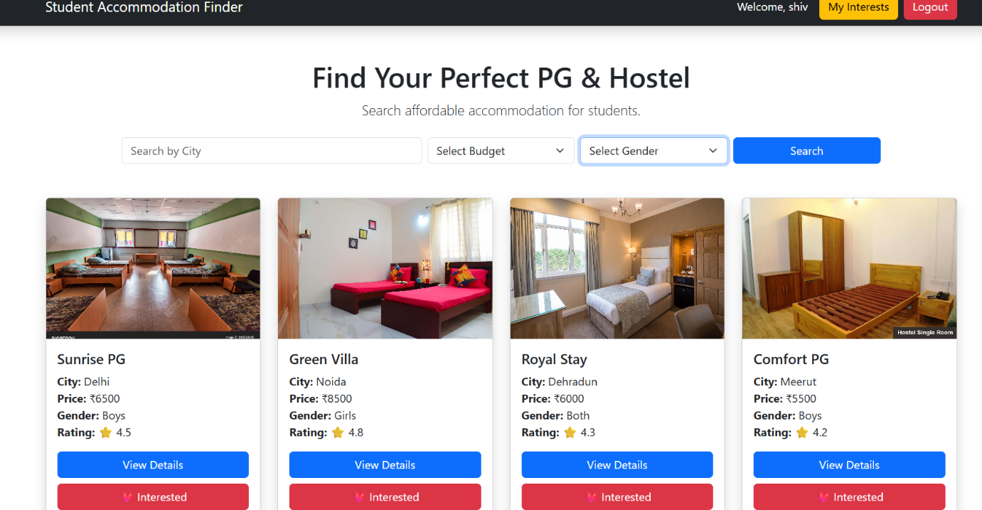
Description:
This screenshot shows the property listing page where users can view available PG and hostel properties with details such as name, location, price, gender and rating.

Screenshot 2: Property Details Page
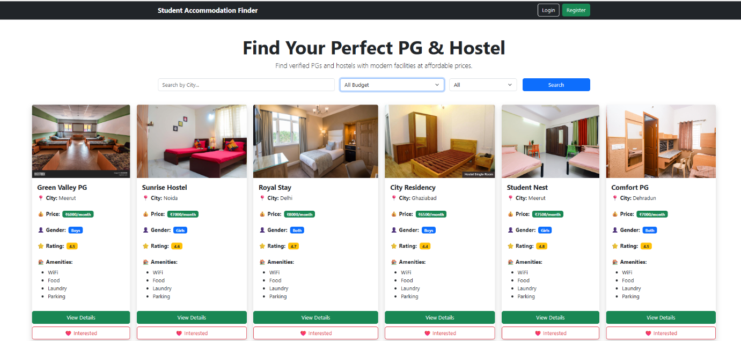
Description:
This screenshot shows the detailed property page containing property information, amenities, description and the option to mark a property as interested.

Screenshot 3: AJAX Interested Button Interaction

Description:
This screenshot demonstrates AJAX functionality where users can add properties to their interested list without refreshing the page.

Screenshot 4: My Interested Properties
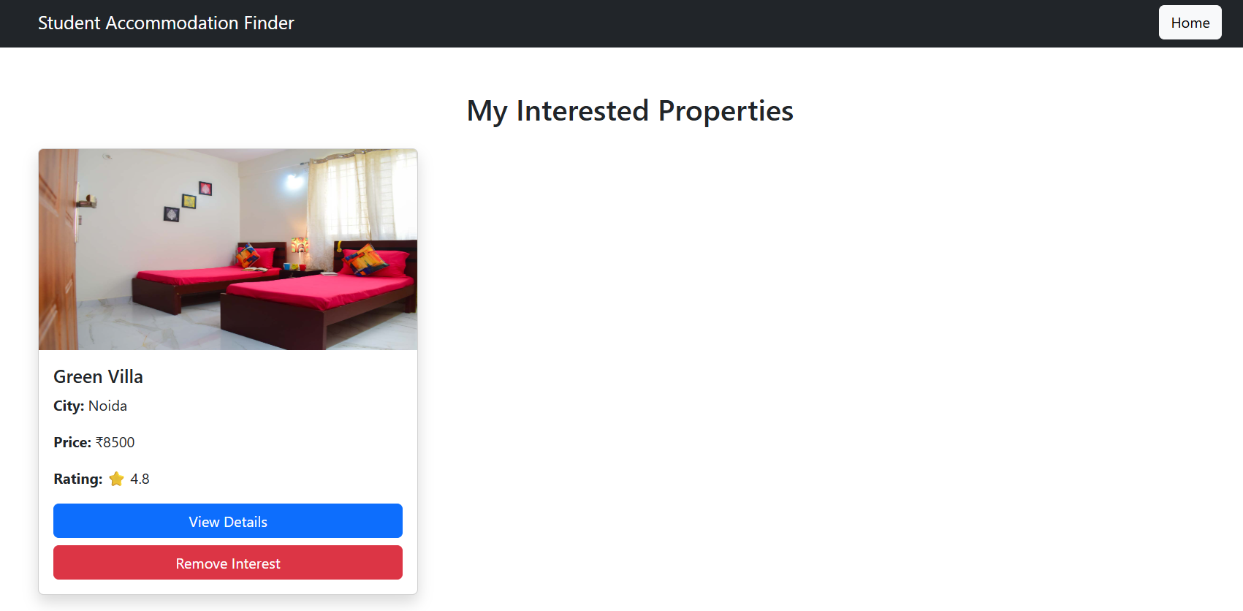

13. Challenges Faced
During development, some challenges were faced:
- Connecting PHP with MySQL database.
- Managing user sessions.
- Implementing AJAX requests.
- Creating relationship between properties and amenities.
- Integrating React with the existing project.

14 Future Enhancements
Future improvements:
- Online booking system.
- Payment integration.
- Google Maps location.
- User reviews and ratings.
- Admin dashboard.
- Real-time availability updates.

15. Conclusion
Student Accommodation Finder successfully provides a digital platform for students to search and manage accommodation options.
The project demonstrates practical implementation of frontend development, backend programming, database management, AJAX communication, and React component development.
The application provides an efficient and user-friendly solution for students looking for PG and hostel accommodations.

